Developed by Paige, J., Graham, L., Sittner, B. (2021)

Simulation Education
Evidence-Based Best Practices

Session 4: Evaluation of Student Learning
Workbook

Developed for Des Moines University

The purpose of this workbook is to provide a resource to further develop your skillset as a simulation educator. Associated with each of the Simulation Education
Evidence-Based Best Practices sessions is a workbook that contains short self-learning activities and resources. Please take some time between sessions to apply what you learned. Prior to the next session, answers and explanations will be provided on the activities designed for each session.

If you have any questions, please don’t hesitate to connect with us.

Jane B. Paige PhD, RN, CNE, CHSE paige@msoe.edu

Leslie Graham RN MN PhD(c) CNCC CHSE CCSNE leslie.graham@durhamcollege.ca

Barbara Sittner PhD, RN, APRN-CNS, ANEF Barbara.Sittner@bryanhealth.org

Healthcare Simulation Standards of Best PracticeTM Participant Evaluation
Link to the Standard. Please read the criteria and the required elements. You can download for free a pdf of the standard.

Selecting the Right Instrument
All instruments/tools contain key performance indicators (KPIs). When choosing an instrument, ask yourself these key questions
- Is the instrument being used for its intended purpose?
- Does the instrument:
  - measure what it important to measure and not too much?
  - posses a reasonable level of complexity to give you meaningful measures?
  - align with existing benchmarks and standards?
  - clearly itemize a list of key KPIs?
  - have a reasonable and management workload for the scorer?

Examples of Instruments
Name of Instrument | Citation
Simulation Culture Organizational Readiness Survey (SCORS) | https://sites.google.com/view/evaluatinghealthcaresimulation/scors
The ISBAR Interprofessional Communication Rubric (IICR) | Foronda, C., & Bauman, E. (2018). ISBAR Interprofessional Communication Rubric. Retrieved from https://sites.google.com/view/evaluatinghealthcaresimulation/iicr
Anesthetists’ Non-Technical Skills System | Fletcher G, Flin R, McGeorge P, Glavin R, Maran N, Patey R. Anaesthetists' Non-Technical Skills (ANTS): evaluation of a behavioural marker system. Br J Anaesth. 2003 May;90(5):580-8
Communication and Teamwork Skills Assessment | Frankel A, Gardner R, Maynard L, Kelly A. Using the Communication and Teamwork Skills (CATS) Assessment to measure health care team performance. Jt Comm J Qual Patient Saf. 2007 Sep;33(9):549-58.
Mayo High-Performance Teamwork Scale | Malec JF, Torsher LC, Dunn WF, Wiegmann DA, Arnold JJ, Brown DA, Phatak V. The mayo high performance teamwork scale: reliability and validity for evaluating key crew resource management skills. Simul Healthc. 2007 Spring;2(1):4-10.
Ottawa Crisis Resource Management Global Rating Scale | Kim J, Neilipovitz D, Cardinal P, Chiu M, Clinch J. A pilot study using high-fidelity simulation to formally evaluate performance in the resuscitation of critically ill patients: The University of Ottawa Critical Care Medicine, High-Fidelity Simulation, and Crisis Resource Management I Study. Crit Care Med. 2006 Aug;34(8):2167-74.
Reliability and Validity
When using an instrument in a new setting, it is important to establish validity and reliability of the instrument within that environment. Denote which of the following statements addresses reliability (R) or validity (V).
- Ability of the instrument to be administered repeatedly, under several situations, or by different evaluators, measuring a stable attribute each time. _____
- A simulation measuring empathy is a good predictor of empathy displayed in the clinical environment. _____
- Administer a measure or instrument to the same people on two occasions or administer a test-retest. _____
- Examine observer scores to see if scores are comparable. _____
- Examining item interrelationships on a knowledge questionnaire. _____
- The 9-item scale had a Cronbach’s alpha of .92. _____
- To establish face validity of a PA checklist, several experts were consulted. _____
- A 6-item performance checklist for Doctor of Physical Therapy was refined after an exhaustive literature review, consultation with subject matter experts, and in-depth conversations with members of the target population. _____
- The degree to which an instrument measures what it claims to measure. _____
Answers at end
New World Kirkpatrick Levels of Evaluation and Examples
^{Level} | Definitions  - Key Points | Examples in the context of training healthcare providers
Level 4: Results | Degree to which targeted outcomes occur as result of the training.  Short-term observations and measurements (leading indicators) suggest critical behaviors that affect desired results. | Desired results align with organizational goals. Leading Indicator examples –  Example of desired result for a simulation program: Recipients of SBE (healthcare providers) positively impact patient outcomes as result of formally trained SBE educators.  - Examples of Leading Indicators (a) simulation program is financially sustainable, (b) educators who conduct simulations are qualified to teach SBE, (c) simulations are evaluated as high quality, (d) educational outcomes are achieved (i.e. regulatory, entry-to-practice exams, accreditation [practice institution or academic setting] (e) clinical outcomes are achieved (i.e. decreased hospital acquired infection rates, reduced medication errors, reduced number of patient falls, increased patient satisfaction scores, reduced readmission rates, decreased mortality and morbidity) .
Level 3: Behavior | Degree to which participants apply what they learned during training when they are back on the job.  - Key actions (critical behaviors) can be observed and measured that lead directly to Level 4 results.  - Processes and systems (required drivers) support and establish accountability.  - Most important level since training alone is not enough.  - Most disruptive to traditional training evaluation practices.  - Continuous monitoring and adjustment. | Example of critical behavior for Simulation Program:  Clinical and academic outcome at or above established benchmark.  Required driver examples  - Reinforce - Opportunities to practice skills learned in simulation, educational sessions, annual skills renewal, communities of practice,  - Monitor - Performance checklists against pre-established competencies, quality committees, 90-day survey, chart audits to evaluate outcomes following training, orientation, mentor feedback.  - Encourage - Health Care Provider works with mentor & receives personalized feedback. Administrators listen to healthcare provider on the challenges of applying what they have learned in SBE to the workplace. A culture exists that values simulation training.  - Reward - Recognition of training and performance occurs (i.e. awards, newsletters, plaques, certificates).
Level 2: Learning | Degree to which participants acquire the intended knowledge, skills, attitudes, confidence, and commitment based on their participation in the training.  - Do not overdo surveys.  - Primarily formative in nature. | Learning component examples  - Knowledge – Learners complete pre-post knowledge tests  - Skill - Learners role-play caring for a patient, conflict resolution, demonstrate skills ie care of chest tube, changing central line dressing  - Attitude – Focus group discussion on benefits of SBE.  - Confidence – Pre-post survey measuring confidence.  - Commitment - Action plan created for application of learning on job.
Level 1: Reaction | Degree to which participants find the training favorable, engaging and relevant to their jobs.  - Keep it simple. Ask only what you will use.  - Formative during training to quickly adjust approach. | - Satisfaction - Trainers use a brief ‘pulse check’ during training (in-person or online) to ask about teaching approach and make immediate adjustments.  - Engagement - Dedicated observers monitor engagement during training session.  - Relevance - A delayed post training survey is completed by educators on relevance once had chance to use.

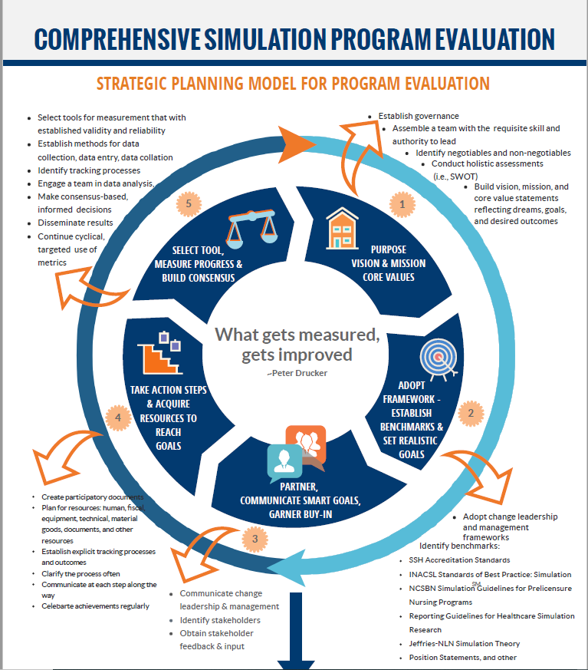
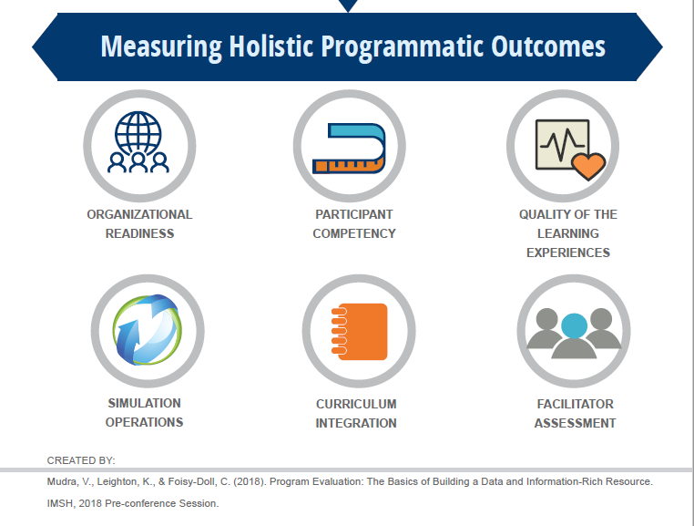
ANSWERS
1. R, 2. V, 3. R, 4. R, 5. V, 6. R, 7. V, 8. V, 9. V
Weblinks
Standards of Best Practice: Simulation©
ASPE Standards of Best Practice
Society for Simulation in Healthcare Dictionary
Evaluating Healthcare Simulation
References
Foronda, C., & Bauman, E. (2018). ISBAR Interprofessional Communication Rubric. Retrieved from https://sites.google.com/view/evaluatinghealthcaresimulation/iicr
Foisy-Doll, C., & Leighton, K. (2018). Simulation champions: Fostering courage, caring, and connection (1st ed.). Wolters Kluwer.
McGaghie, W., Draycott, T., Dunn, W., Lopez, C., & Stefanidis, D. (2011). Evaluating the impact of simulation on translational patient outcomes. Simulation in Healthcare, 6(August supplement). https://doi.org/10.1097/SIH.0b013e318222fde9
McGaghie, W. C., Issenberg, S. B., Barsuk, J. H., & Wayne, D. B. (2014). A critical review of simulation-based mastery learning with translational outcomes. Medical Education, 48(4), 375–385. https://doi.org/10.1111/medu.12391
Onwochei, D. N., Halpern, S., & Balki, M. (2017). Teamwork Assessment Tools in Obstetric Emergencies: A Systematic Review. Simulation in Healthcare, 12(3). https://journals.lww.com/simulationinhealthcare/Fulltext/2017/06000/Teamwork_Assessment_Tools_in_Obstetric.5.aspx
Paige, J. B., Graham, L., & Sittner, B. (2020). Formal Training Efforts to Develop Simulation Educators: An Integrative Review. Simulation in Healthcare, 15(4).
Santomauro, C. M., Hill, A., McCurdie, T., & McGlashan, H. L. (2020). Improving the Quality of Evaluation Data in Simulation-Based Healthcare Improvement Projects: A Practitioner’s Guide to Choosing and Using Published Measurement Tools. Simulation in Healthcare, 15(5).
Watkins, S. C., de Oliveira Filho, G. R., Furse, C. M., Muffly, M. K., Ramamurthi, R. J., Redding, A. T., Maass, B., & McEvoy, M. D. (2021). Tools for Assessing the Performance of Pediatric Perioperative Teams During Simulated Crises: A Psychometric Analysis of Clinician Raters’ Scores. Simulation in Healthcare, 16(1).
Watkins, S. C., Roberts, D. A., Boulet, J. R., McEvoy, M. D., & Weinger, M. B. (2017). Evaluation of a Simpler Tool to Assess Nontechnical Skills During Simulated Critical Events. Simulation in Healthcare, 12(2).

