Developed by Paige, J., Graham, L., Sittner, B. (2021)

Simulation Education
Evidence-Based Best Practices

Session 3: Debriefing
Workbook

Developed for Des Moines University

The purpose of this workbook is to provide a resource to further develop your skillset as a simulation educator. Associated with each of the Simulation Education
Evidence-Based Best Practices sessions is a workbook that contains short self-learning activities and resources. Please take some time between sessions to apply what you learned. Prior to the next session, answers and explanations will be provided on the activities designed for each session.

If you have any questions, please don’t hesitate to connect with us.

Jane B. Paige PhD, RN, CNE, CHSE paige@msoe.edu

Leslie Graham RN MN PhD(c) CNCC CHSE CCSNE leslie.graham@durhamcollege.ca

Barbara Sittner PhD, RN, APRN-CNS, ANEF Barbara.Sittner@bryanhealth.org

Healthcare Simulation Standards of Best PracticeTM
Debriefing Standard
Link to the Debriefing Standard. Please read the criteria and the required elements. You can download for free a pdf of the standard.
https://www.nursingsimulation.org/article/S1876-1399%2816%2930129-3/fulltext

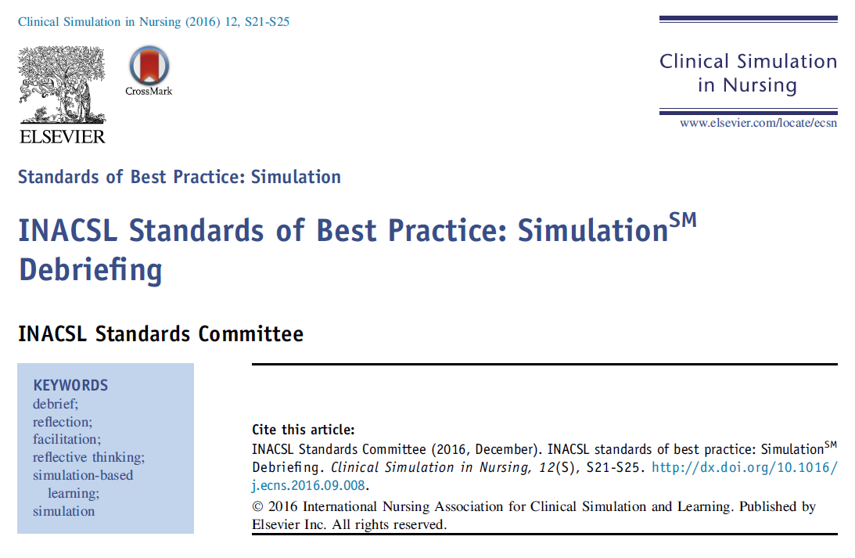
Gather – Analyze – Summarize
Cheng (2012)
Action | Gather | Analyze | Summarize
Various events from the simulation | Review facts of the case that just occurred  • What happened when you first entered the room?  • [learner name] did a lot of things very well in this case. What specifics did you notice that [name] did well?  • After [____], what happened next?  • After [____], how did the patient respond?  • How did the scenario end? | Ask questions to understand learner thought process.  • What was your differential during this case?  • I noticed you chose to [____], tell us about your thought process at that point.  • What part of that case was particularly challenging? Why?  • What unanswered questions do you have about this type of patient presentation? | What are the take home points?  • What is your take home point?  • If you saw this case during your shift tomorrow, what do you want to make sure you remember?  • If you did this simulation again, is there anything you would do differently?
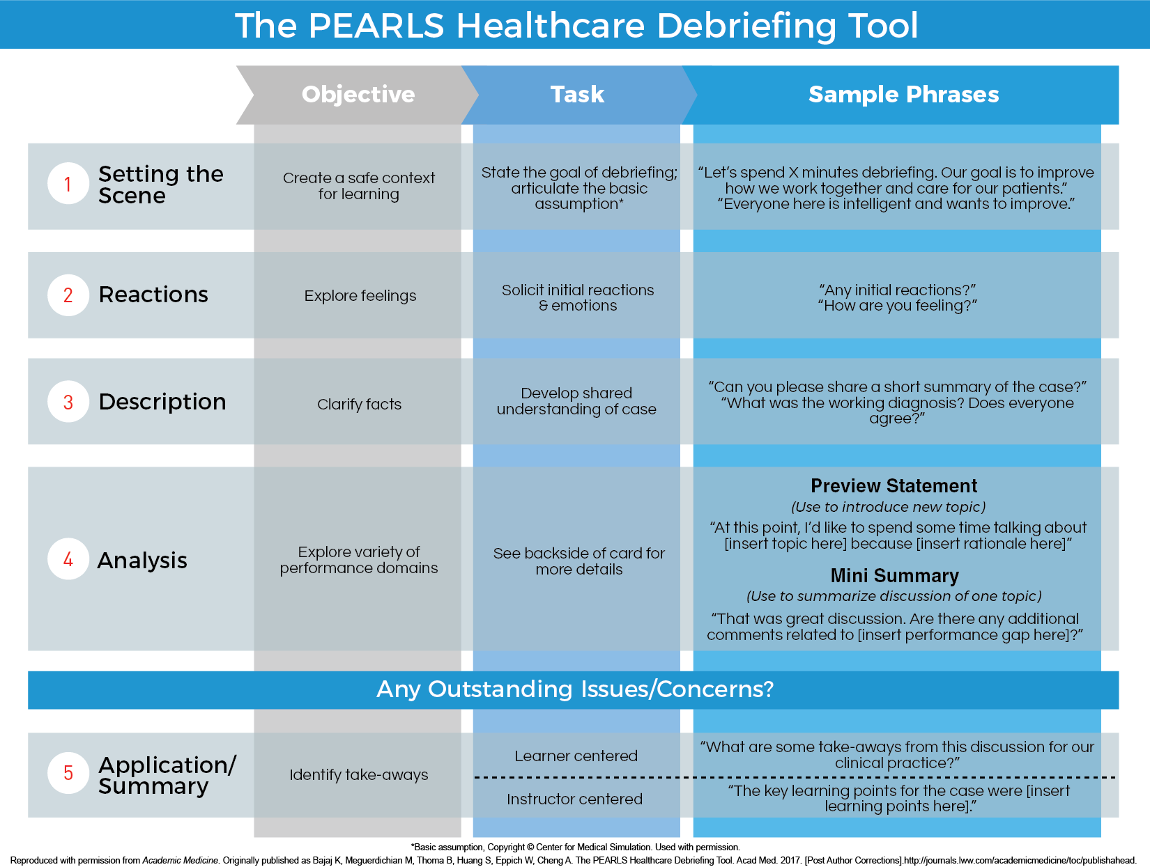
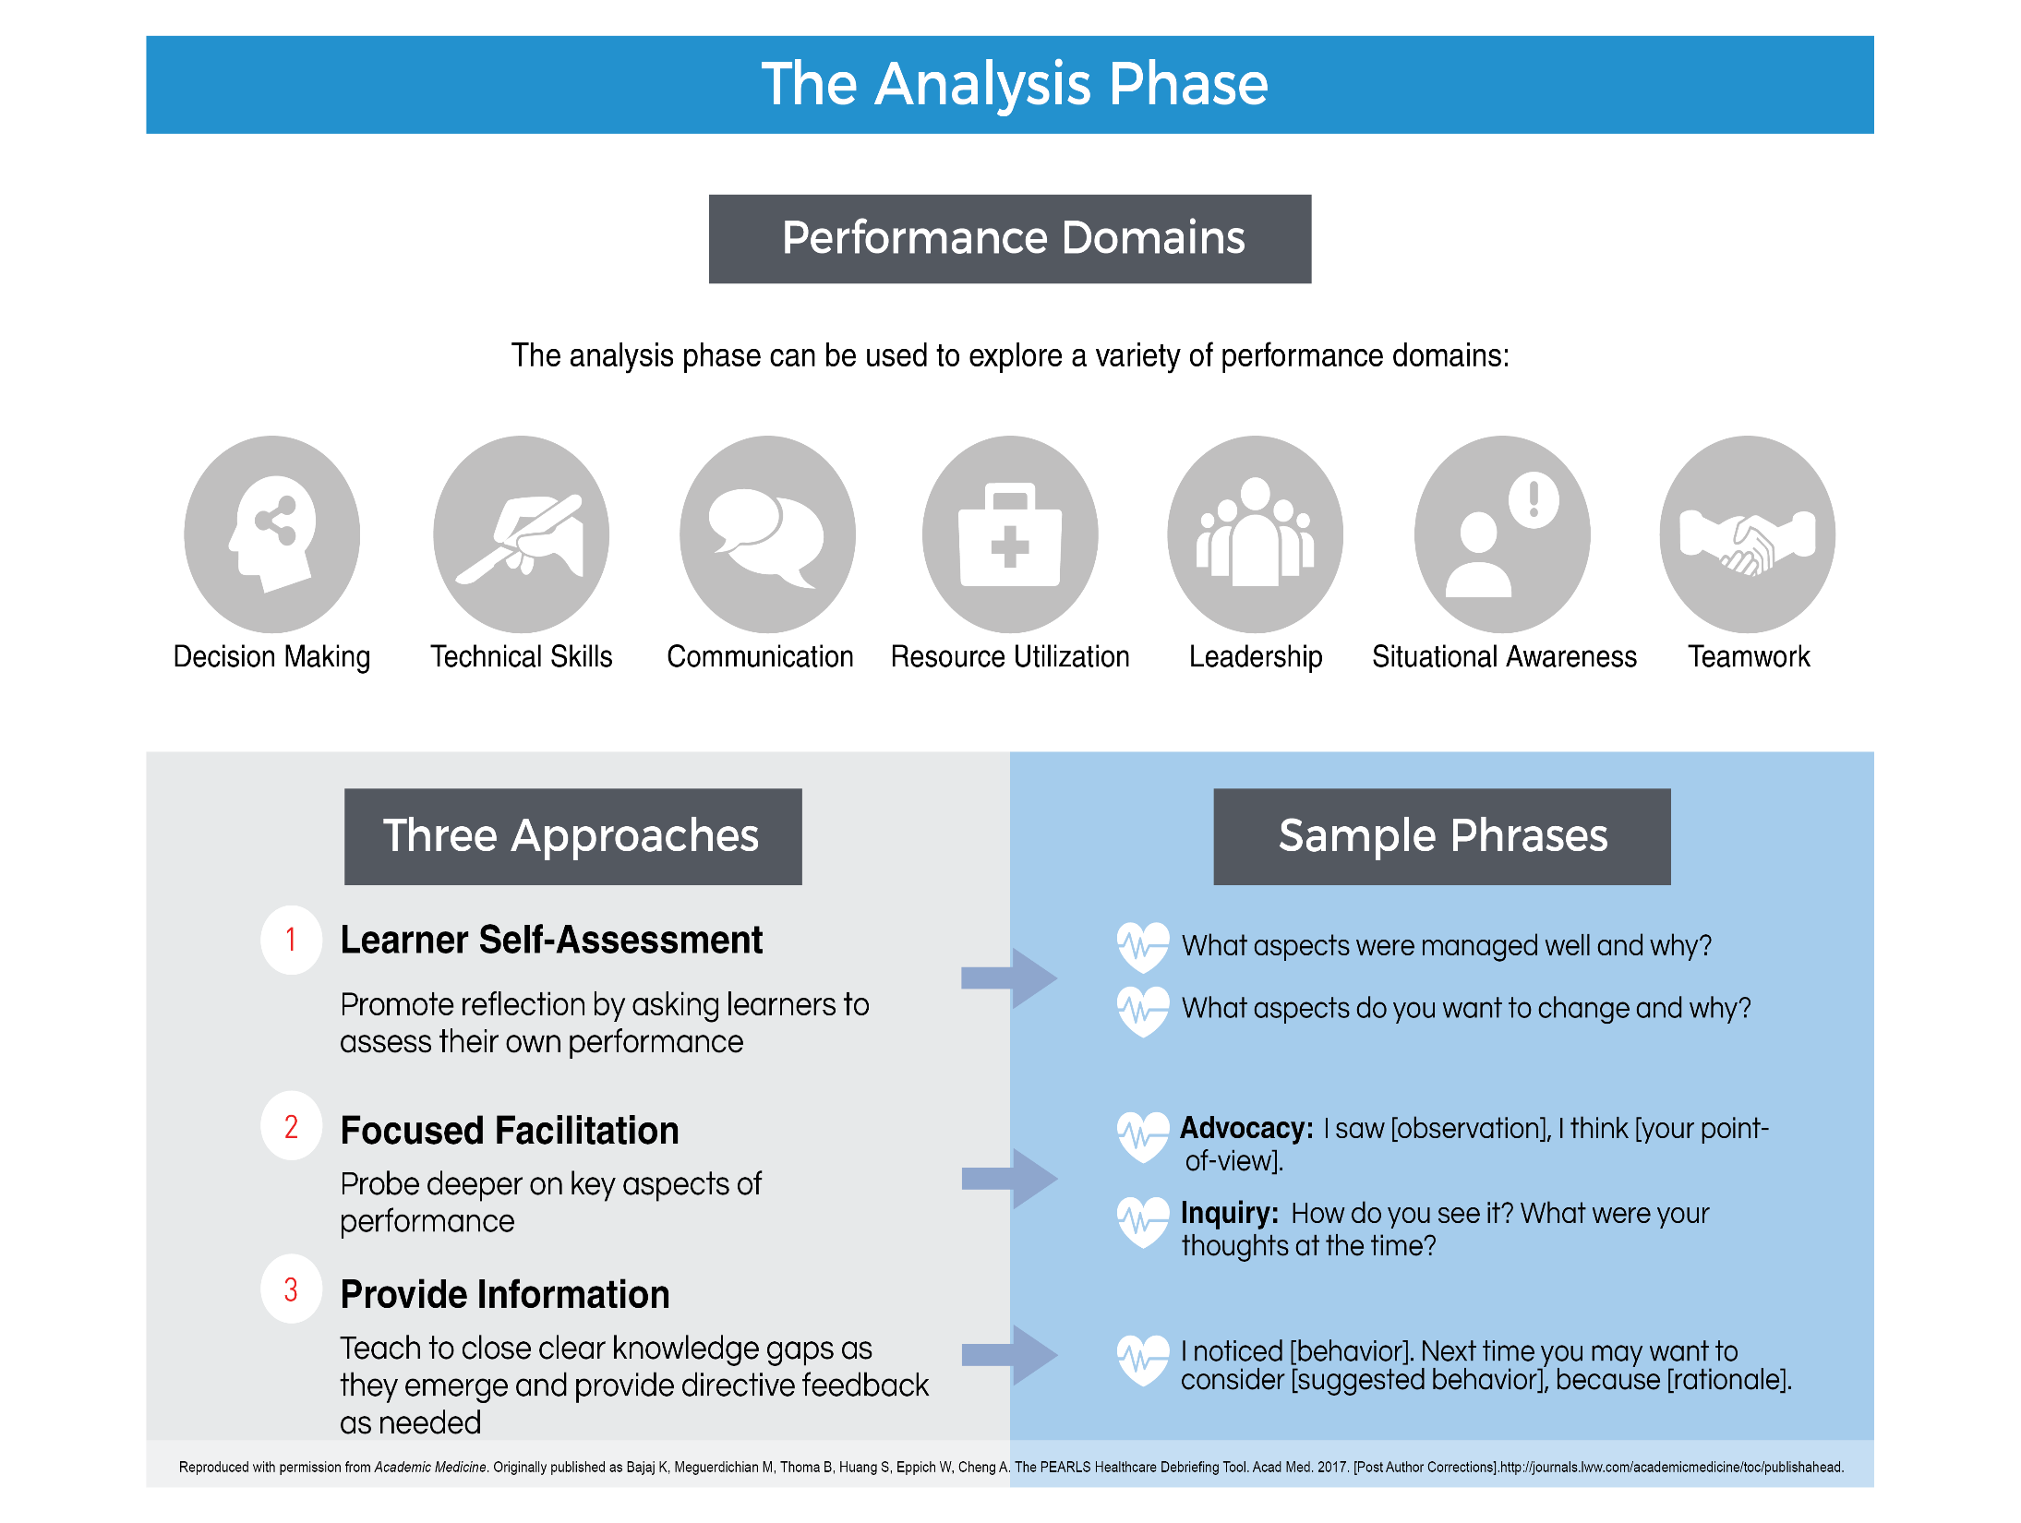Debriefing for Meaningful Learning
Here is link to developing website. You can request specific worksheets and resources.
https://dmldebriefing.com/
Key Point about DML
- DML is grounded in well-established, constructivist, and problem-based learning theories and has demonstrated positive student thinking and learning outcomes.
- Uncovered taken-for-granted assumptions
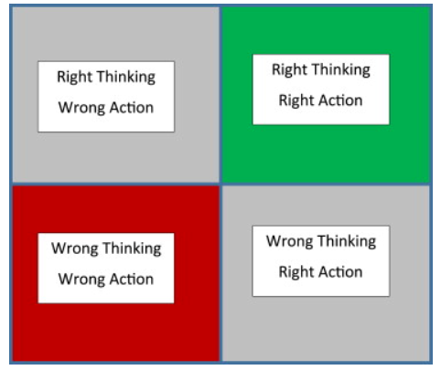
- Six phases for debriefing E5 developed by Bybee et al. (1989): engage, explore, explain, elaborate, evaluate, and extend
  - Engage - note the first thing that comes to mind about the clinical encounter, (c) list what went right, (d) list what did not go well or could have been done differently.
  - Explore from the clinical experience from the perspective of the roles they had. Use worksheet to map the care of the patient including central problemes, are of concern; link relationships.
  - Explain interactive process between learner and teacher articulating the thinking processes. Use of Socratic questioning.
  - Elaborate or emphasise the knowledge, skills, attitudes evident in the clinical experience and explain missing pieces.
  - Evaluate what went well and what did not go well. Set the experience in their memory with the decisions, actions, and better choices for next time.
  - Extend the clinical experience by thinking-beyond-action by asking ‘what if’ questions for next time experiences a similar clinical experience.

Activity #1: Critique the Debriefing Session
Compare and contrast the following debriefing sessions:
- Do they follow best practices for debriefing?
- Is psychological safety created and maintained?
- Does the facilitator foster a deep reflection?
- How does the facilitator use Socratic questioning to enhance the learning?
Debriefing A
https://www.youtube.com/watch?v=A7hJTuRyu2U
Debriefing B
https://www.youtube.com/watch?v=nG-RWn0Xcbo

Activity #2: Difficult Debriefing Situations
Useful article: Difficult debriefing situations: A toolbox for simulation educators (Grant, Robinson, Catena, Eppich, Cheng, 2018)
Here are several case studies to discuss with your colleagues. Use suggested strategies from Grant et al. 2018) article (next page)
Case Study #1
The facilitator is about to commence the debriefing for the five team members immediately after the simulation. First, psychological safety was established by reminding the group of confidentiality, reviewing expectations, time frame, and the importance of all to participate. When the facilitator asked one of the participant's why they delayed in commencing CPR, to which the participant defensively stated, “well in the hospital I would have done right away!!” and crossed her arms across her chest angrily. How would the facilitator manage this debriefing?
Case Study #2 (from Grant et al., 2018)
You are about to debrief two students (one medical, one nursing) who have just completed a simulation scenario of an infant who is apneic. During the simulation, the students fail to identify apnea despite the fact that the saturations were persistently low. In the debriefing, both students are visibly upset that they made this critical error. They fail to make eye contact and don’t provide a reaction to your initial question in regards to their initial thoughts.

Communication Tools (from Grant et al., 2018)
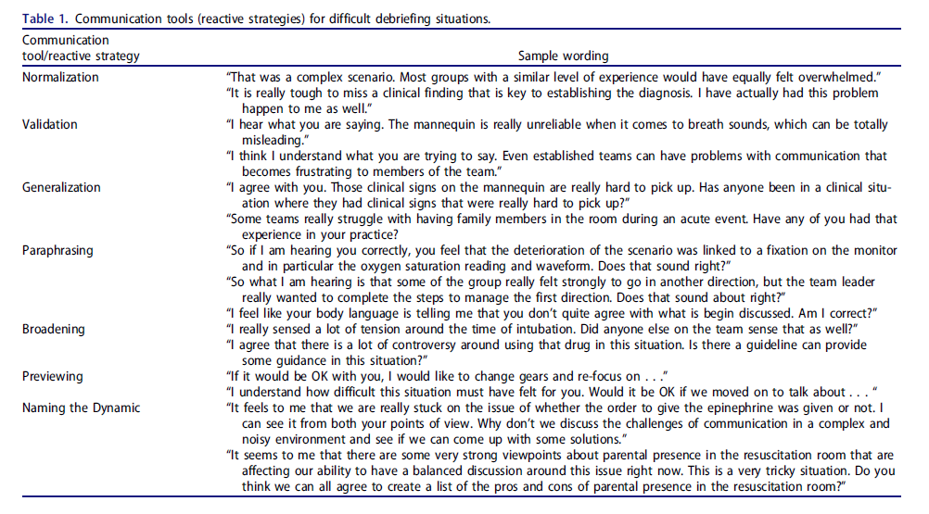
Ongoing Activity - My Personal Development Plan
Focus | Short Term | Long Term | Resources I need | Deliverable
Assessment of Learners

Prebriefing

Cueing during simulation
Debriefing

Learner evaluation

Curricular integration

IPE

Scenario Design

Weblinks
Standards of Best Practice: Simulation©
ASPE Standards of Best Practice
Society for Simulation in Healthcare Dictionary

Coursera Course (George Washington University) (12:28 min) by Kris Dreifuerst (sign up for three free courses) https://www.coursera.org/lecture/clinicalsimulations/the-basics-of-debriefing-in-simulation-SE1Bn
Simulation in Health Care: Debriefing in Healthcare Simulation Advanced Skills Royal College of Physicians and Surgeons of Canada. (12:58 min) https://youtu.be/rpkVUUY-AGk

Debrief2Learn
https://debrief2learn.org/

References
Abulebda, K., Srinivasan, S., Maa, T., Stormorken, A., & Chumpitazi, C. E. (2020). Development, Implementation, and Evaluation of a Faculty Development Workshop to Enhance Debriefing Skills Among Novice Facilitators. Cureus, 12(2), e6942. MEDLINE. https://doi.org/10.7759/cureus.6942
Bajaj, K., Meguerdichian, M., Thoma, B., Huang, S., Eppich, W., & Cheng, A. (2018). The PEARLS Healthcare Debriefing Tool. Academic Medicine, 93(2), 336. https://doi.org/10.1097/ACM.0000000000002035
Cheng, A., Grant, V., Robinson, T., Catena, H., Lachapelle, K., Kim, J., Adler, M., & Eppich, W. (2016). The Promoting Excellence and Reflective Learning in Simulation (PEARLS) Approach to Health Care Debriefing: A Faculty Development Guide. Clinical Simulation in Nursing, 12(10), 419–428. rzh. https://doi.org/10.1016/j.ecns.2016.05.002
Cheng, A., Palaganas, J., Eppich, W., Rudolph, J., Robinson, T., & Grant, V. (2015). Co-debriefing for simulation-based education: A primer for facilitators. Simulation in Healthcare, 10(2), 69. https://doi.org/10.1097/SIH.0000000000000077
Cheng, A., Rodgers, D. L., van der Jagt, É., Eppich, W., & O’Donnell, J. (2012). Evolution of the Pediatric Advanced Life Support course: Enhanced learning with a new debriefing tool and Web-based module for Pediatric Advanced Life Support instructors. Pediatric Critical Care Medicine : A Journal of the Society of Critical Care Medicine and the World Federation of Pediatric Intensive and Critical Care Societies, 13(5), 589–595. https://doi.org/10.1097/PCC.0b013e3182417709
Dreifuerst, K. (2012). Using debriefing for meaningful learning to foster development of clinical reasoning in simulation. Journal of Nursing Education, 51(6), 326-333. DOI:10.3928/01484834-20120409-02
Dreifuerst, K. (2012). Using debriefing for meaningful learning to foster development of clinical reasoning in simulation. The Journal of Nursing Education, 51(6), 326–333. https://doi.org/10.3928/01484834-20120409-02
Grant, Robinson, Catena, Eppich & Cheng (2018). Difficult debriefing situations: A toolbox for simulation educators, Medical Teacher, 40:7, 703-712, DOI: 10.1080/0142159X.2018.1468558
Jaye, P., Thomas, L., & Reedy, G. (2015). “The Diamond”: A structure for simulation debrief. Clinical Teacher, 12(3), 171–175. https://doi.org/10.1111/tct.12300
Rudolph, J., Simon, R., Dufresne, R., & Raemer, D. (2006). There’s no such thing as “nonjudmental” debriefing: A theory and method for debriefing with good judgment. Simulation in Healthcare, 1(1), 49–55.
Sawyer, T., Eppich, W., Brett-Fleegler, M., Grant, V., & Cheng, A. (2016). More Than One Way to Debrief: A Critical Review of Healthcare Simulation Debriefing Methods. Simulation in Healthcare: The Journal of the Society for Simulation in Healthcare, 11(3), 209–217. https://doi.org/10.1097/SIH.0000000000000148

