Developed by Paige, J., Graham, L., Sittner, B. (2021)

Simulation Education
Evidence-Based Best Practices

Session 1
Introduction to Simulation
Workbook

Developed for Des Moines University

The purpose of this workbook is to provide a resource to further develop your skillset as a simulation educator. Associated with each of the Simulation Education
Evidence-Based Best Practices sessions is a workbook that contains short self-learning activities and resources. Please take some time between sessions to apply what you learned. Prior to the next session, answers and explanations will be provided on the activities designed for each session.

If you have any questions, please don’t hesitate to connect with us.

Jane B. Paige PhD, RN, CNE, CHSE paige@msoe.edu

Leslie Graham RN MN PhD(c) CNCC CHSE CCSNE leslie.graham@durhamcollege.ca

Barbara Sittner PhD, RN, APRN-CNS, ANEF Barbara.Sittner@bryanhealth.org

Supporting Background for Formal Training of Simulation Educators
- One component to developing a simulation program is the importance of training simulation educators. As Simulation-based Experiences (SBE) becomes the norm for healthcare education, faculty/educator preparation in SBE takes on a greater role to deliver quality experiences.
- It is essential to develop faculty/educators’ skill in teaching with SBE as effective training of simulation educators is related to higher achievement of learner outcomes (Beroz, 2017; Rizzolo et al., 2015; Zigmont et al., 2011).
- Use of SBE for teaching and learning requires a related but different skill set from traditional classroom and clinical teaching (Kolbe & Rudolph, 2018; Topping et al., 2015).
- Limited guidelines exist for the design of training courses for simulation educators, which contributes to inconsistency in training topics, duration and delivery method of the training experience (Clapper, 2010; Kinnear et al., 2015).
- A review of the literature appraised training efforts for SBE (Paige et al., 2020). Specifically, three aims were to: (a) summarize the topics covered in formal SBE training programs; (b) describe the structure of SBE training programs; (c) explore evaluation methods of simulation educators. Findings from this review offer ideas for developing simulation educators.
- Of note, is that 80% percent of the time and effort in developing training programs is the planning part (Caffarella, Daffron, 2013).

Activity #1: Formative, Summative, and High-Stake Simulations
Complete this chart differentiating type of simulation based on level of evaluation.
 | ^{Formative} | ^{Summative} | ^{High Stakes}
^{Purpose}

^{Timing}

^{Tools}

^{Unique features}

^{Comments}

Activity 2 - Formulating Evaluation Plan: Kirkpatrick Model
- Review the New World Kirkpatrick Model and the examples for each of the 4 levels of evaluation table.
- Complete the table to match type of evaluation to Kirkpatrick level of evaluation
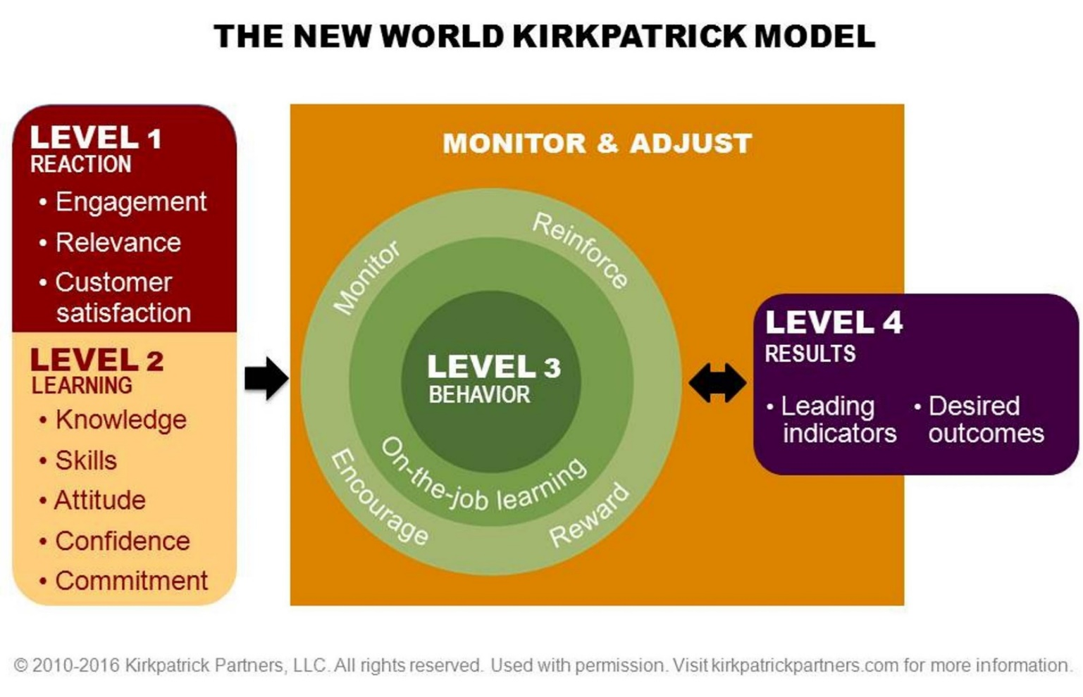
Kirkpatrick's Four Levels of Training Evaluation by Kirkpatrick, Wendy Kayser; Kirkpatrick, James D. Reproduced with permission of Association for Talent Development in the format Republish in presentation/slides via Copyright Clearance Center.
KLE Level 4 (RESULTS): Degree to which targeted outcomes occur as result of the training.
- Desired results align with organizational goals.
Example of desired result for a Simulation Center: Recipients of simulation-based education positively impact patient outcomes.
- Examples of Leading Indicators (a) educators who conduct simulations are qualified to teach SBE, (b) simulations are evaluated as high quality, (d) interprofessional training partnerships are established (c) clinical outcomes are achieved (i.e. decreased hospital acquired infection rates, reduced medication errors, reduced number of patient falls, increased patient satisfaction scores).
KLE Level 3 (BEHAVIOR): Degree to which participants apply what learned during training back on job.
- Key actions (critical behaviors) are observed. Processes (required drivers) support & establish accountability. Most important level since training alone not enough. Most disruptive to traditional training evaluation practices.
Example of critical behavior for Simulation Program:
- Clinical and academic outcome at or above established benchmark.
Examples of required drivers:
- Reinforce - Opportunities to practice skills learned in simulation, educational sessions, annual skills renewal, communities of practice
- Monitor - Performance checklists against pre-established competencies, quality committees, chart audits to evaluate outcomes following training, orientation, mentor feedback.
- Encourage - Health Care Provider works with mentor & receives personalized feedback. A culture exists that values simulation training.
- Reward - Recognition of training and performance occurs (i.e. awards, newsletters, plaques, certificates).
KLE Level 2 (LEARNING): Degree to which learners acquire the intended knowledge, skills, attitudes, confidence, & commitment based on training.
Examples of learning components:
- Knowledge – Learners complete pre-post knowledge tests
- Skill - Learners role-play caring for a patient, demonstrate skills i.e. care of chest tube, changing central line dressing
- Attitude – Focus group discussion on benefits of SBE.
- Confidence – Pre-post survey measuring confidence.
- Commitment - Action plan created for application of learning on job.
KLE Level 1 (REACTION): Degree to which learners find the training favorable, engaging and relevant to their jobs.
- Keep it simple. Ask only what you will use. Formative during training to quickly adjust training approach.
Examples:
- Satisfaction - Trainers use a quick ‘pulse check’ during training to ask about teaching approach to immediately adjust.
- Engagement - Dedicated observers monitor engagement during training sessions.
- Relevance - Post training survey on relevance once had chance to use knowledge gained.

Fill in column 2 on the type of evaluation based on Kirkpatrick level of evaluation
Example of a survey item, a question, or data point | Identify whether a level 4 [results], level 3 [behavior], level 2 [learning], or level 1 [reaction]
I found the instructor’s debriefing style supportive
List 4 of the major things you learned in the simulation
The topic of the simulation is relevant to my future career
The cueing by the facilitator helped me in my learning
Learners completing the program of study achieve a 100% pass rate for professional certification
I have been able to apply what I have learned in a clinical situation
Alumni have advanced in career position at 2-year mark
I feel confidence in applying what I learned in a clinical situation
Clinical instructor evaluates learner’s ability to intubate a patient in practice
I found the simulation materials easy to follow

Activity #3: Simulation Modalities
Now it’s time to think about different simulation modalities that can be used in your course(s). This doesn’t mean you need to implement all the modalities; it’s something that will build over time.
Directions:
- In the table below, identify a topic where a simulation modality could be added to your course.
- Be prepared to share an example when we meet next time.

Course | Topic | Simulation Modality | Example
Example:  Safe Practices in Anesthesia | Fire in the OR | Virtual Reality | Link to Video clip  Fire in the OR™ Virtual Reality Simulation | Medical Training For Surgical Fires - YouTube
References and Weblinks
Resources - Weblinks
Standards of Best Practice: Simulation©
ASPE Standards of Best Practice
Society for Simulation in Healthcare Dictionary
Healthcare Simulationist Code of Ethics
Society for Simulation in Healthcare (SSH) Organization

Recourses – Virtual Gaming
Canadian Alliance CAN Sim (VSG)
http://can-sim.ca/virtual-simulation-games-vsg/
http://can-sim.ca/hc/

Resources – Selected Articles
Beroz, S. (2017). A statewide survey of simulation practices using NCSBN Simulation Guidelines. Clinical Simulation in Nursing, 13(6), 270–277. https://doi.org/10.1016/j.ecns.2017.03.005
Boulet JR. (2008). Summative Assessment in Medicine: The Promise of Simulation for High-stakes Evaluation. Academic Emergency Medicine, 15(11), 1017–1024. CINAHL Complete. https://doi.org/10.1111/j.1553-2712.2008.00228.x
Clapper, T. C. (2010). Beyond Knowles: What those conducting simulation need to know about adult learning theory. Clinical Simulation in Nursing, 6(1), 7–14. https://doi.org/10.1016/j.ecns.2009.07.003
Kinnear, J., Smith, B., Akram, M., Wilson, N., & Simpson, E. (2015). Using expert consensus to develop a simulation course for faculty members. The Clinical Teacher, 12(1), 27–31. mdc. https://doi.org/10.1111/tct.12233
Kolbe, M., & Rudolph, J. W. (2018). What’s the headline on your mind right now? How reflection guides simulation-based faculty development in a master class. BMJ Simulation and Technology Enhanced Learning, 4(3), 126. https://doi.org/10.1136/bmjstel-2017-000247
Paige, J. B., Graham, L., & Sittner, B. (2020). Formal Training Efforts to Develop Simulation Educators: An Integrative Review. Simulation in Healthcare, 15(4). https://journals.lww.com/simulationinhealthcare/Fulltext/2020/08000/Formal_Training_Efforts_to_Develop_Simulation.8.aspx
Rizzolo, M. A., Kardong-Edgren, S., Oermann, M., & Jeffries, P. (2015). The National League for Nursing project to explore the use of simulation for high-stakes assessment: Process, outcomes, and recommendations. Nursing Education Perspectives, 36(5). https://doi.org/10.5480/15-1639
Topping, A., Bøje, R. B., Rekola, L., Hartvigsen, T., Prescott, S., Bland, A., Hope, A., Haho, P., & Hannula, L. (2015). Towards identifying nurse educator competencies required for simulation-based learning: A systemised rapid review and synthesis. Nurse Education Today, 35(11), 1108–1113. https://doi.org/10.1016/j.nedt.2015.06.003
Willhaus, J., Burleson, G., Palaganas, J., & Jeffries, P. (2014). Authoring Simulations for High-Stakes Student Evaluation. Clinical Simulation in Nursing, 10(4), e177-82. CINAHL Complete. https://doi.org/10.1016/j.ecns.2013.11.006
Zigmont, J., J., Kappus, L., J., & Sudikoff, S., N. (2011). Theoretical foundations of learning through simulation. Seminars in Perinatology, 35(2), 47–51. https://doi.org/10.1053/j.semperi.2011.01.002

